Anna, a girl who loved dolphins.

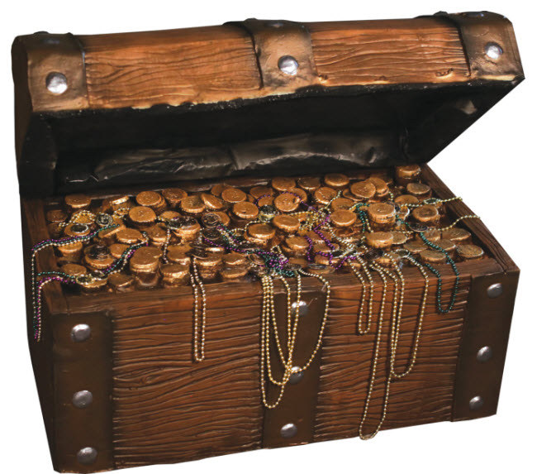
As a child, Anna loved dolphins. She dreamed of diving into the water and finding dolphins. Little did she know but her dream would come true. When she grew up her dream came true; she became a diver. And she saw lots of dolphins. One day she got her diving stuff on and dove into the water. Splash! She went down, down, down into the water. She thought that if she went farther down she would see a dolphin so she went farther down some more. She didn’t realize that she would get to the bottom of the ocean. But when she did she saw a sunken ship. She decided to explore it. After a little bit she saw a treasure chest so she brought it to the surface of the water. Weeks later she lived in a mansion and had servants, gold, thrones, and other riches. Anna thought she was the luckiest girl ever!

